**ASSIGNMENT – 5**

**PROBLEM STATEMENT:**

Write a python program to store first year percentage of students in array. Write function for sorting array of floating point numbers in ascending order using

a) Selection Sort

b) Bubble sort and display top five scores.

Bubble Sort is the simplest sorting algorithm that works by repeatedly swapping the adjacent elements if they are in wrong order.

**SELECTION SORT**

The selection sort algorithm sorts an array by repeatedly finding the minimum element (considering ascending order) from unsorted part and putting it at the beginning. The algorithm maintains two subarrays in a given array.

1) The subarray which is already sorted. 2) Remaining subarray which is unsorted.

In every iteration of selection sort, the minimum element (considering ascending order) from the unsorted subarray is picked and moved to the sorted subarray.

**CODE :**

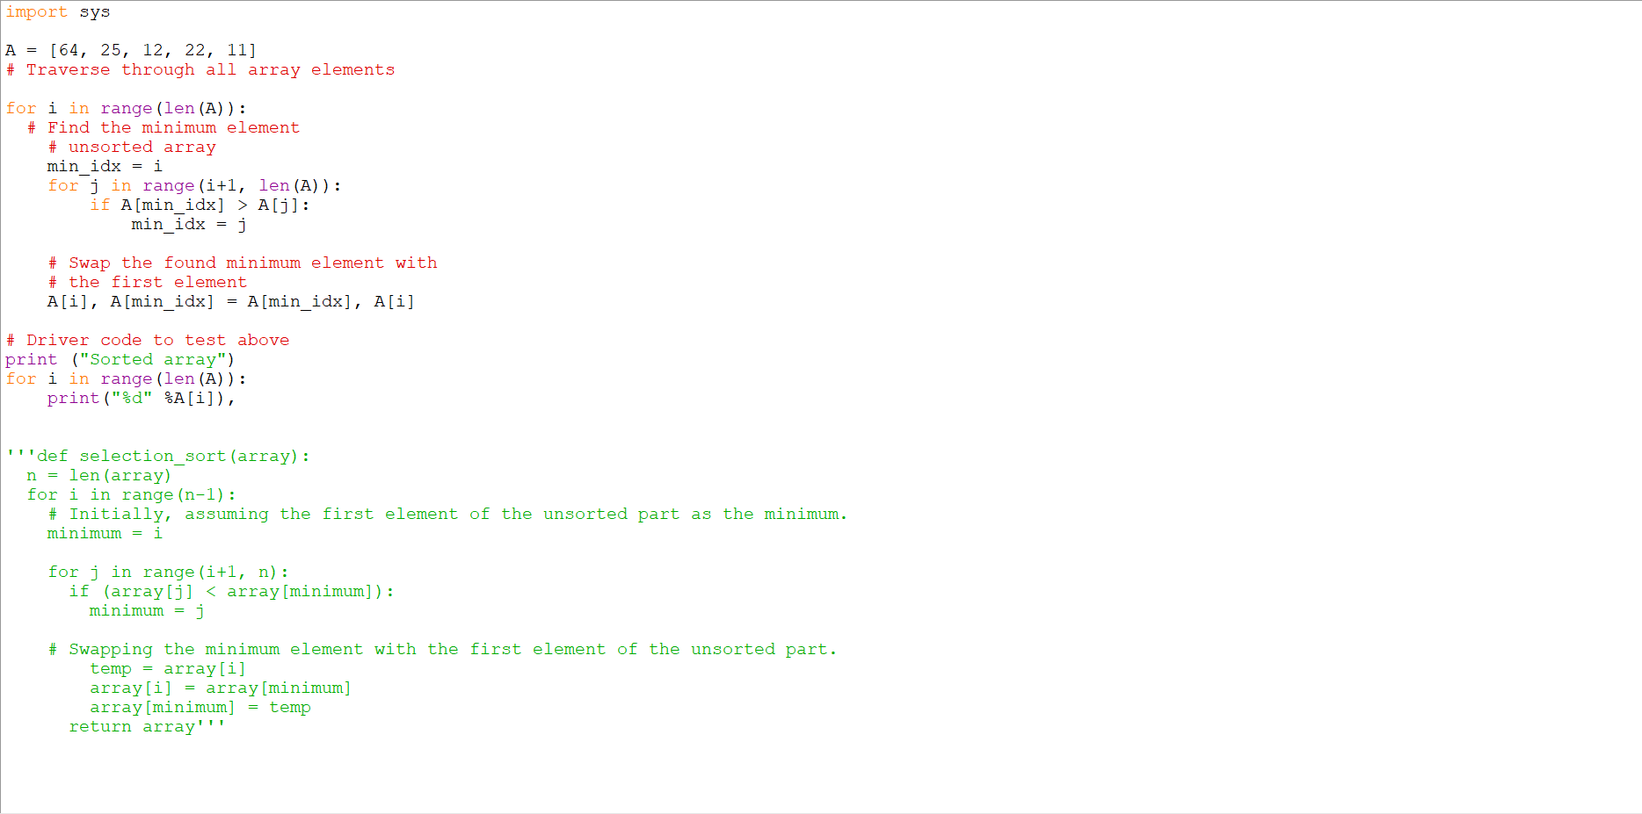

**OUTPUT:**

